|  |  |
| --- | --- |
| **Project Case** |  |
| COMP6232001 | COMP6800 | COMP6800001  Human and Computer Interaction |
| **Computer Science** | **E232-COMP6800-VT05-00** |
| ***Valid on*** *Even Semester Year 2022/2023* | **Revision 00** |

1. Kelompok tidak diperkenankan untuk:

*Members of the group are prohibited from:*

* + - Melihat sebagian atau seluruh jawaban kelompok lain,

*Seeing a part or the whole answer from other groups,*

* + - Menyadur sebagian atau seluruh jawaban dari buku, catatan, video, dan jenis referensi lainnya,

*Retell a part or the whole answer from books, notes, videos, and other references,*

* + - Menyadur sebagian atau seluruh jawaban dari internet,

*Retell a part or the whole answer from the internet,*

* + - Mengumpulkan jawaban yang tidak sesuai dengan tema soal,

*Submitting an answer with a different theme from the given case,*

* + - Melakukan tindakan yang menyebabkan jawaban dicontek oleh orang lain atau kelompok lain, baik disengaja maupun tidak disengaja,

*Doing action that could result the answer being copied by someone or other groups, intentionally or unintentionally,*

* + - Melakukan tindakan kecurangan lainnya.

*Committing other dishonest actions.*

1. Jika kelompok terbukti melakukan tindakan seperti yang dicantumkan pada butir ke-1, maka nilai mahasiswa dan/atau kelompok yang melakukan kecurangan, baik menyontek atau dicontek, akan dinolkan sesuai dengan peraturan yang berlaku.

*If it has been proven that a group has committed dishonest actions outlined in point 1 above, the whole groups related to the incident, regardless of which one copies or has their answer copied, will be issued a score of zero according to the regulation.*

1. Jawaban yang dapat diterima dan dinilai adalah jawaban yang dikumpulkan sebelum batas waktu yang telah ditentukan.

*The answer must be submitted before the designated deadline to be accepted and graded,*

1. Jawaban akan dinilai berdasarkan teknik atau metode yang diajarkan pada kelas praktikum dengan menggunakan software yang sudah ditentukan.

*The scoring will be based on the materials taught during the practicum classes using the designated software. Using different software than requested may result in your answer not being graded.*

1. Jika Anda tidak membaca peraturan ini, maka Anda dianggap sudah membaca dan menyetujuinya.

*By taking this exam, you agree to these regulations, regardless of whether you have read it or not.*

1. Persentase penilaian untuk matakuliah ini adalah sebagai berikut:

*The score will be distributed as follows:*

|  |  |  |
| --- | --- | --- |
| **Tugas Mandiri**  *Assignment* | **Proyek**  *Project* | **UAP**  *Final Exam* |
| - | 100% | - |

1. Perangkat lunak yang digunakan pada matakuliah ini adalah sebagai berikut:

*This course uses the following software:*

|  |
| --- |
| **Software**  *Software* |
| Chrome / Firefox / Microsoft Edge  Figma  Visual Studio Code |

1. Ekstensi file yang harus dikumpulkan untuk matakuliah ini adalah sebagai berikut:

*Your answers must be in the following file extensions:*

|  |  |  |
| --- | --- | --- |
| **Tugas Mandiri**  *Assignment* | **Proyek**  *Project* | **UAP**  *Final Exam* |
| - | FIG, HTML, CSS, JS, Image Files (JPG / PNG) | - |

1. File yang harus dikumpulkan adalah keseluruhan jawaban beserta dengan aset yang digunakan (gambar, audio, video, dll) dan dokumentasi proyek yang berisikan link referensi aset dan penjelasan mengenai aplikasi yang dibuat (terlampir bersama dengan soal).

*Include other files that can support your project, such as: all files in your project, other files (image, audio, video, etc.) used in your project, *.doc file (documentation of your project) that contains all pages in your project, reference links of additional files (image, audio, video, etc.) used in your project, the description about how to use your application, etc.*

## Soal

*Case*

**VhoTel**

**VhoTel** is a legendary hotel in Jakarta open since 1999 providing impeccable service for its guests. **VhoTel** has an assortment of rooms from 2 beds room, 1 beds room, to a luxurious suite with 3 bedroom and a kitchen. It also provides facilities like spas, gyms, and pools to accommodate their guests’ needs.

Because **VhoTel** has been around for a long time, **VhoTel** plans to change the appearance of their website to provide new atmosphere for the customer. First, **VhoTel** needs to create a **website prototype** and **company website** that represents the **VhoTel** image. With this website, **VhoTel** hopes to improve service to their customers. **VhoTel** entrusts you as a web designer to design their **website prototype** and create a **company website**.

The **requirements** from **VhoTel** Shop are described below:

* + - 1. **VhoTel** wants you to design the **website prototype** of all **five pages** before making the HTML files. The website prototype will be created using **Figma**. Ensure the website prototype that you created is the **exact same** with the website that you will make later. Each pagewill contain **header**, **navigation**, **content,** and **footer** as its structure. Consider the **color**, **layout**, and **consistency** when designing the prototype.
      2. **VhoTel** wants you to build the **website attractive**, **appealing**, **fully functional**, and make sure the website is **responsive**. The website should be accessible using a mobile phone in a perfect way. To achieve that, use **5 kinds of CSS property** and **JavaScript**. Use **meta** **viewport** **tag** and **media** **screen** **rule** that will be applied if the screen is **below** **768px** screen width.
      3. The website consists of **five main pages**. They are **Home Page**, **About Us Page**, **Our Rooms Page**, **Our Facilities Page**, and **Reservation Page**. Below are the **requirements** for each page:
* **Home Page**

This page will show the **promotion event banners** for promotion events that **VhoTel** is having for its guests.

* **About Us Page**

This page will contain the **history and story** of **VhoTel** so that guests can understand and know more about **VhoTel**.

* **Our Rooms Page**

This page will show **all types of rooms** available in **VhoTel** such as **their picture, and their specifications**, so that guests can know details about the rooms in **VhoTel**.

* **Our Facilities Page**

This page will display **all the facilities provided** by **VhoTel** for guests to enjoy.

* **Reservation Page**

This page will contain a **reservation form** for the guest to **book a room in VhoTel**. The guest will need to provide **details about the reservation and their personal information**, such as **name, email, check in date, check out date, and type of room**. You are asked to create **5 kinds of form components** and **5 kinds of validation**. For validation, you must create it using **JavaScript** and **don’t use regular expression**.

**Guidelines:**

* + - * 1. Design your website by observing the principles of **human and computer interaction**. Set up your site as **creative** as possible but still strive for **consistency**.
        2. The **website prototype** must be designed using **Figma** and make suretocreate some **features**, such as color and text style, effect, component, variant or interactive component, and navigation.
        3. Consider the **color**, **font**, **size**, and **layout** that you use to design the prototype and website.
        4. All pages mentioned in the requirement should be created **based on your template design**.
        5. Use only **external** **CSS**. Internal or inline CSS will not be marked.
        6. Use **CSS box positioning** to design your web structure**,** do not use table for the layout.
        7. Consider the **language** you use, including spelling and grammar, feel free to choose either Bahasa or English, but you cannot have both at the same time.
        8. Make your website **responsive** so it can deliver in any size, particularly for **desktops**, **tablets,** and **mobile devices**.
        9. Organize your files with subdirectories.
        10. Include references (link from a website, book, etc.) that you use in creating the website.

**If you do not understand, please ask your assistant!**

**Dokumentasi   
Page Figma**

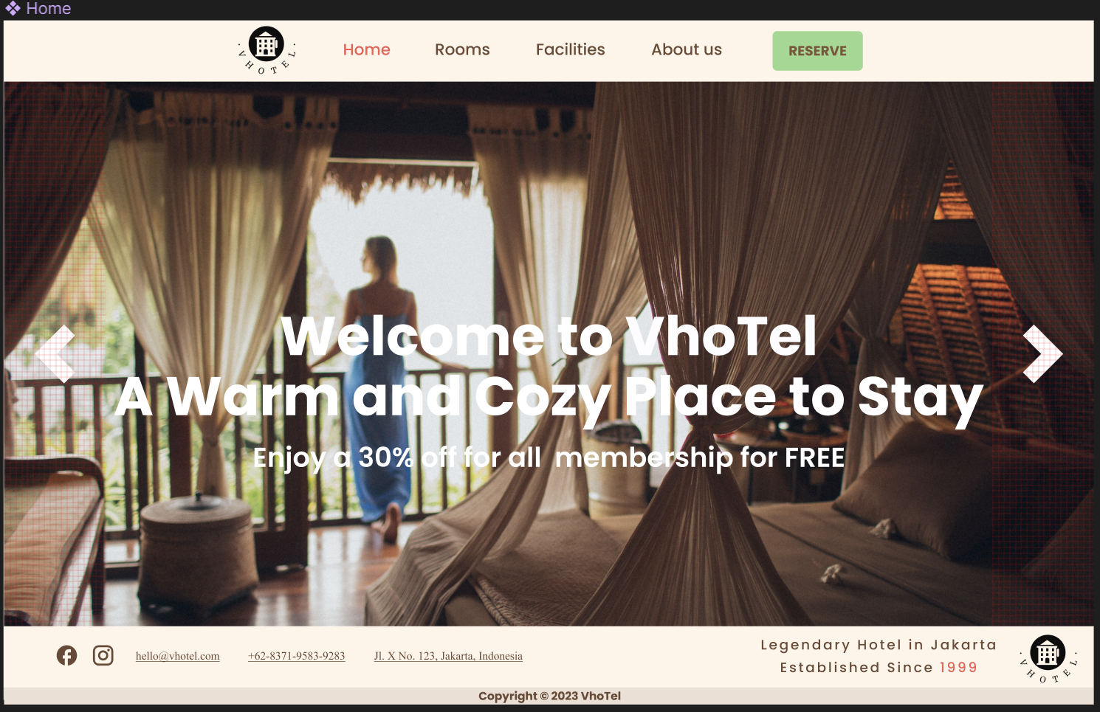

Home page terdiri tampilan gambar yang dapat di geser manual dengan klik panah yang tersedia di kanan / kiri, header dan footer, serta promosi event yang berisi diskon untuk membership secara gratis

Rooms berisikan pilihan pilihan ruangan yang dapat di pilih user, dengan informasi di setiap ruangan pilihan, serta saat reserve akan di pindahkan ke page Reservation

Facilities berisikan fasilitias yang disediakan hotel, serta penjelasan singkat dari fasilitas tersebut.

Page reserve berisikan pilihan pilihan tombol dan validasi dari 5 tipe seperti validasi email, validasi nama, validasi date checkin, validasi checkout date, dan pilihan ruangan yang terdiri dari 3 ruangan

Page about us yang berisikan penjelasan singkat tentang hotel dan hal yang ada di dalam hotel

Link referensi:  
<https://www.pexels.com/>